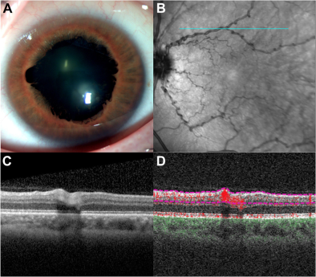

A 42-year-old man with multisystem smooth muscle dysfunction syndrome associated with a heterozygous ACTA2 gene mutation[c.536G>A, p.(Arg179His)] presented for routine ophthalmic examination. He had a history of prune belly syndrome, patent ductusarteriosus, aortic dissection, and abdominal aortic aneurysm. Best-corrected visual acuity was 20/20 in each eye. Anterior segment examination revealed mydriasis with scalloped pupillary margins, and persistent pupillary membranes extending from iris collarettes (A).Fundus examination and near-infrared imaging revealed significant retinal arteriolar corkscrew tortuosity both in the posterior pole andperiphery (B). OCT (C) and OCT angiography (D) demonstrated corkscrew vessel elongation into the outer nuclear layer. Based on the provided images and clinical description please make an ophthalmic diagnosis for this patient. And output the diagnostic conclusions only.

**Multisystem Smooth Muscle Dysfunction Syndrome**